Early Years at

Mareham Le Fen C of E Primary School

Routines

The pupil entrance gate at the side opens for the children to come in at 8.40am. Children in Reception should come into the school via the playground entrance with an adult and into the cloakrooms.

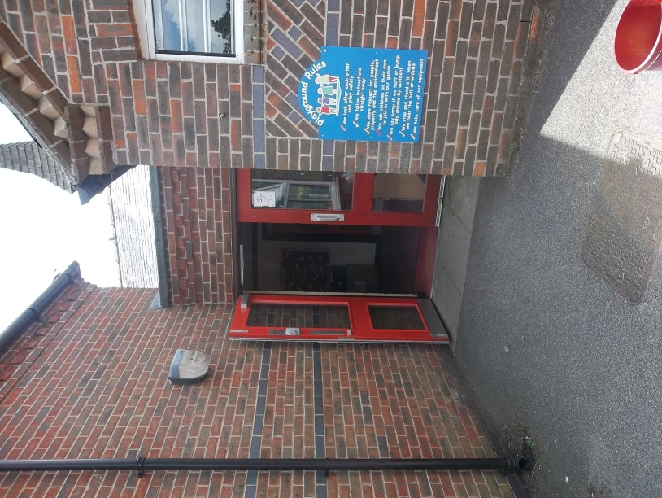

Packed lunches should be placed on the trolleys near the entrance

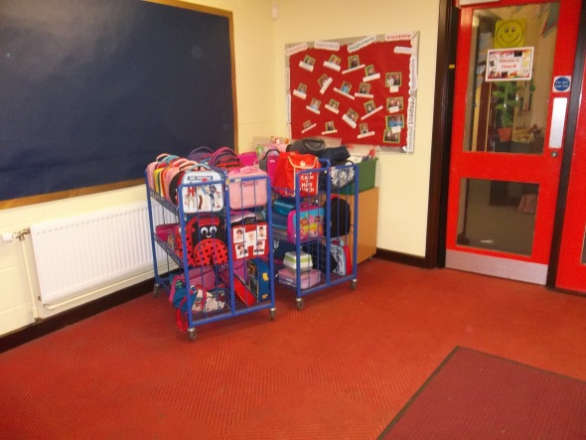
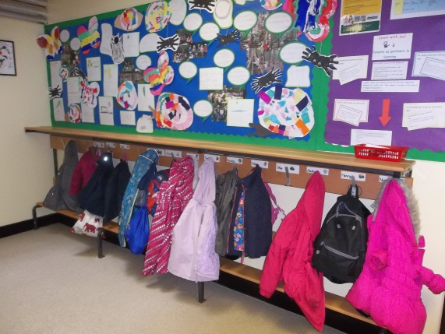

and children need to hang up their bags and coats on the named pegs outside Class S.

There is a box just inside the classroom door for children to place their book bags each morning.

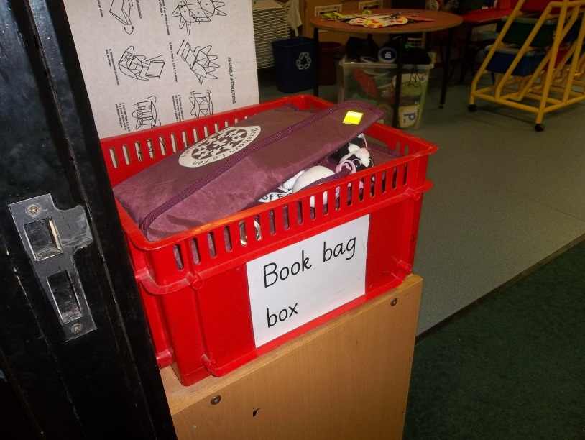

On entering the classroom children will have access to a variety of activities.

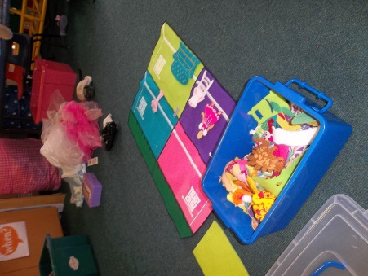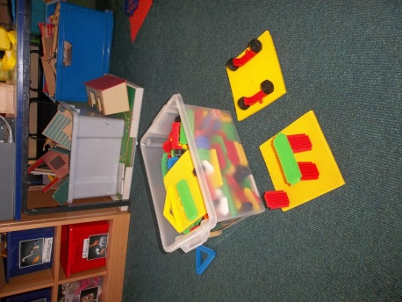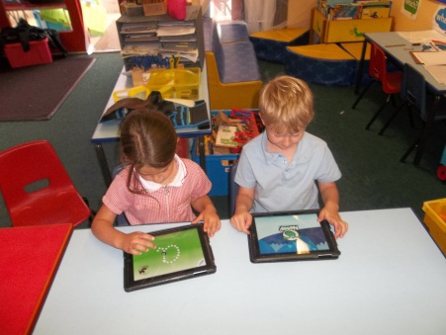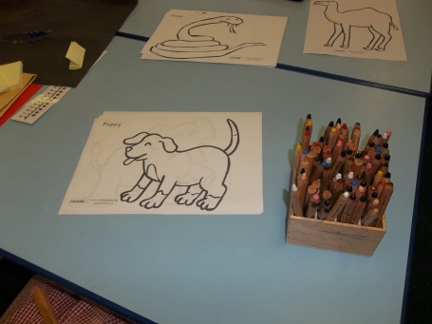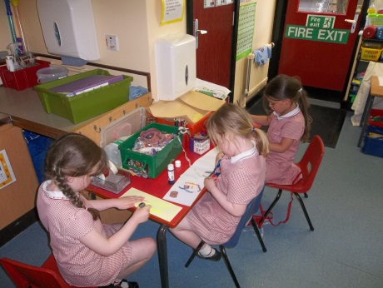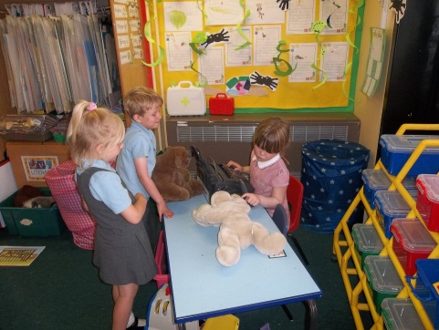
Parents can say goodbye to their child in the classroom ready for registration at 8.50am and exit the school the way they entered.

The gate is locked again at 8.50am so any late arrivals should enter via the front door.

The children join together on the carpet for the whole class register in the morning and after lunch.

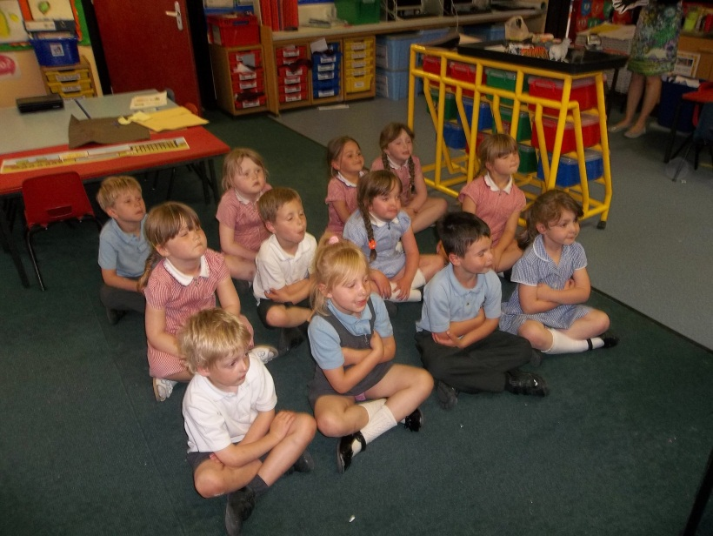

The reception class join with the whole school for assembly on a daily basis. This takes place in the school hall.

At snack time children are provided with a piece of fruit and a drink of water or milk.
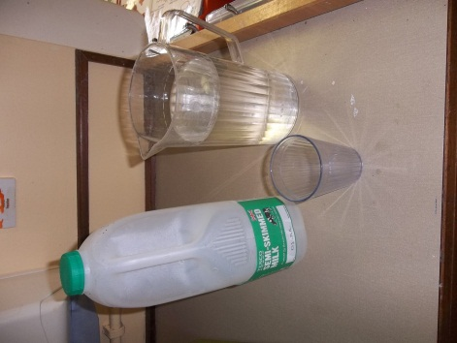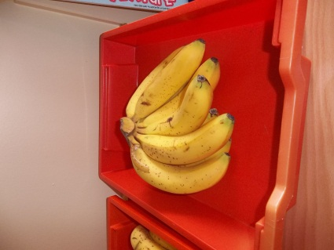
Water helps children to concentrate and drinking regularly is encouraged. Children have access to drinking water all through the day.

Playtime is taken with the rest of the school in the morning from 10.20 – 10.35am and at lunchtime.

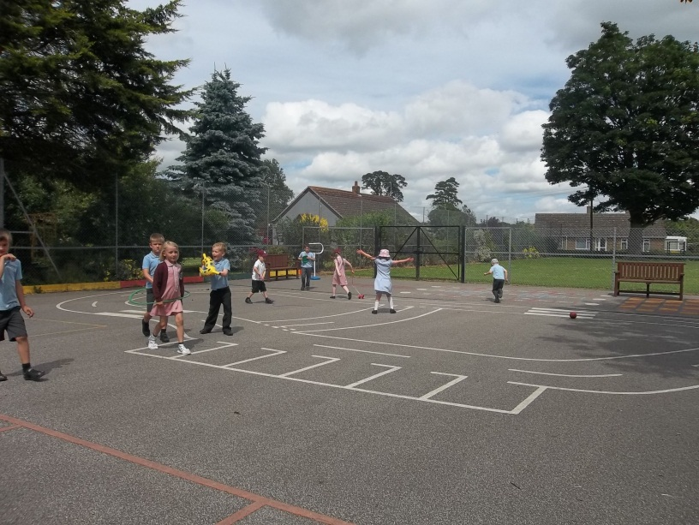

Children are supervised by staff members on the playground.

Lunch is eaten in the hall where are team of midday supervisors look after the children and provide help when needed. All children in Reception, Year 1 and Year 2 are entitled to a free lunch from September 2014. Ours are provided by The Farm Kitchen. Parents will be provided with a login so they can view the menus and order meals in advance.
After lunch there is time to play on the playground which is supervised by the lunchtime supervisors.

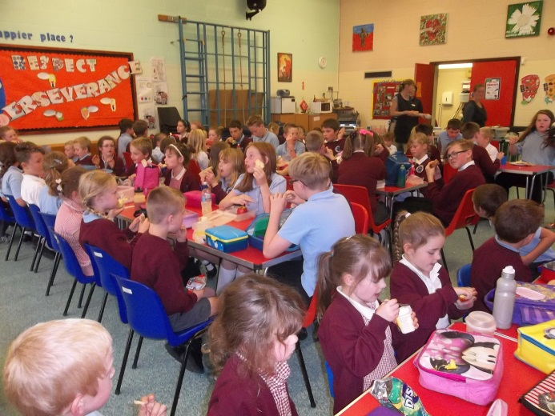
At the end of the school day Class S children are collected from the classroom side door at 3pm, accessed through the side gate. If anyone other than the child’s parent is collecting their child, please inform the class teacher or school office, before the end of the day. Messages must not be sent via the children as these can be forgotten.

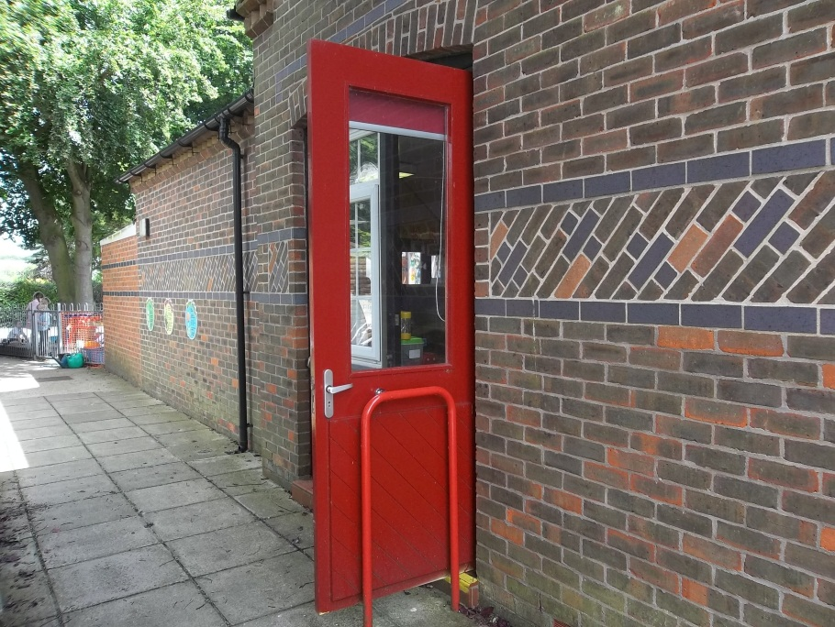

The Learning Environment
As well as two classrooms, the children have access to an enclosed outside learning area.

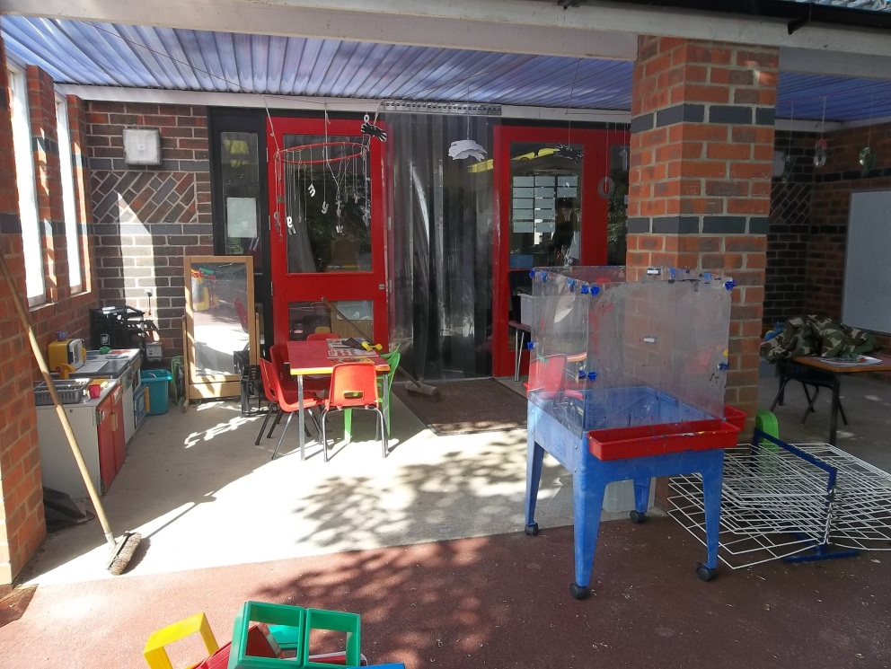

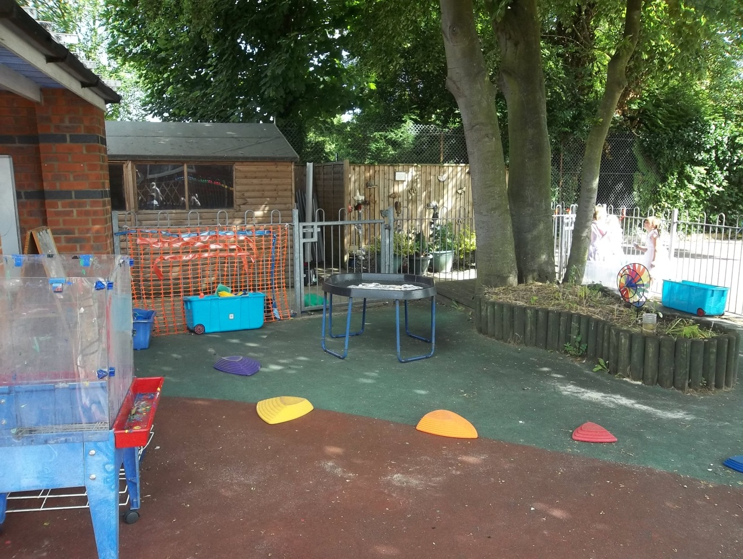

The learning environment changes depending on the interests and needs of the children.

Reading
Children begin by listening to stories. They will first be given a book to share. The children are encouraged to choose from a range of books which they share at home. Children will sometimes be given books without words to introduce characters from the reading scheme while they develop phonic knowledge in school.

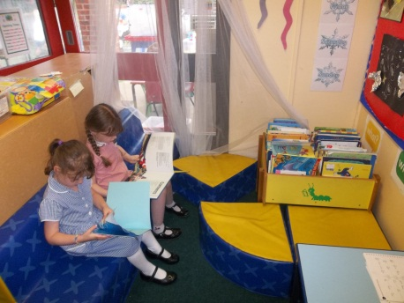

Children will be given ‘tricky words’ to learn to read on sight, when they are ready. These are words that are difficult to blend using phonics such as ‘was’ ‘to’ ‘the’

Children will have a reading log and parents should record books that have been shared and those the children read for pleasure.

Phonics
We teach discrete phonics sessions daily. We follow the Letters and Sounds programme and use Jolly Phonics actions. We run phonics workshops every year for parents. (The first session for parents will be early in the Autumn term) Helping your child at home with their phonics in the early stages of their education will ensure a sound basis for developing their reading and literacy skills.

EYFS and the ‘Learning Journey’
In Reception we take photographs and video your children as they learn in order to record their progress. This carries on from the Learning Journeys and Profiles your child will have had in nursery.
We encourage parents to contribute to the learning journeys in order to get a balanced picture of the progress your child is making across the ‘Early Learning Goals’.

Attendance
At our school we firmly believe that for a child to reach their potential they have to have a good school attendance record which is why we monitor absences closely. Please notify the school by 9.30am on the first day of illness and each day your child is off. While we appreciate not all doctors/dentists appointments can be made during the holidays or after school we do ask that children are only absent from school for the shortest time possible to attend them.
Our full attendance policy can be viewed on our website.

Medicines
The school is happy to administer medicines if the relevant paperwork is completed. This is available from the school office or can be printed from the website. If your child needs an inhaler please provide a named one which can be kept in school every day. Again a medicine form will need to be completed for this. (GPs will usually give a second inhaler that can be kept in school) It is parents’ responsibility to check inhalers are still in date.

Eye tests
Children should ideally have an eye test every year. These are so important, as many children are very good at compensating for poor vision and don’t realise that the way they see something is different to a person with good vision.

Allergies/food intolerances
Please complete this information on the emergency contact sheet which was part of your pack of paperwork. If anything changes, please ensure the school office is notified.

Communication
The school prefers to notify parents of events via text/email. This is only effective if parents regularly check their phones and emails for messages.
Whilst we encourage parents to communicate with us via email, please do not use this method to inform us of any changes to the normal going home procedure as there may not be anyone in the office to act on it.

